www.npmc.org.uk
01908 619912
npmcprivateservices@gmail.com

Basic Knee Exercises

- Try to stand and walk as normally as possible. Your physiotherapist can help you to use any walking aid correctly, if required.

- If lying down on your back, try not to place a towel under the knee as this can lead to some muscles becoming tight.

- Avoid wearing a support all the time. If required, it should be used for periods of higher activity, such as sport.

- If swelling persists, wrap a bag of frozen peas in a wet towel and put it on your knee for 15 – 20 minutes. Repeat up to 3 – 4 times per day.

Complete the following exercises 10 times and repeat 3 times each day. Stop any exercises that feel unsuitable and do not push through pain.

Exercise 1

- Straighten your involved leg as much as possible, tightening the muscles on top of your thigh.
- Hold for ten seconds, and then relax.

Repeat 10 times.

Exercise 2

- Place a rolled towel under one leg to bend it about six inches.
- Raise the lower part of your leg until your knee is straight.
- Hold for about ten seconds, and then relax.

Repeat 10 times.

Exercise 3

- Straighten the involved leg as much as possible, tightening the muscles on top of the thigh.
- Raise your heel off the surface approximately four inches.
- Hold for ten seconds, then slowly return to the starting position and relax.

Repeat 10 times.

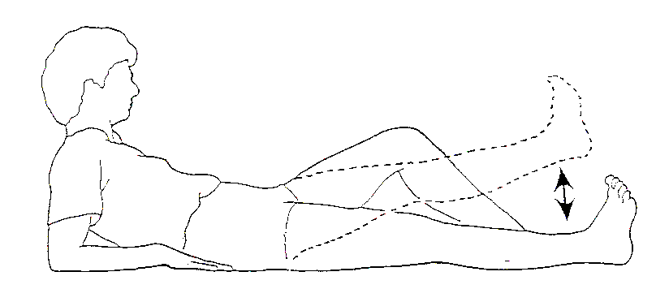

Exercise 4

- Lie on your back with your legs out straight.
- Keep your kneecap pointed toward the ceiling throughout the exercise.
- Slowly slide your foot back toward your buttocks, bending your knee and hip.
- Slower lower the leg to the starting position.

Repeat 10 times.

