www.npmc.org.uk
01908 619912
npmcprivateservices@gmail.com

Plantar Fasciitis

Plantar fasciitis is inflammation at the site where the fascia (a tough band of fibrous tissue) attaches under the heel bone. It’s the most common cause of discomfort around this area. Plantar fasciitis frequently affects people with inflammatory arthritis but it can also occur in people without arthritis. Research has shown that plantar fasciitis is sometimes caused by the shortening of the Achilles tendon and that exercises to lengthen it may help.

Grasp the toes and pull them towards you
Hold for 20 seconds
Repeat 3 times

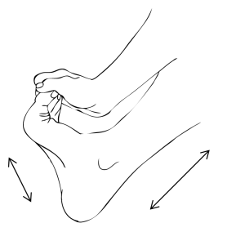

Place a golf ball under the arch of your foot and placing some weight through the ball move the ball around under the arch. You can do this for several minutes.
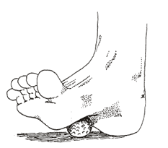

Place a towel over the ball of the foot and pull the toes towards you
Hold for 20 seconds
Repeat 3 times

Stand with hands arms length from a wall. Place the affected foot on the floor as far as you can while keeping the heel on the floor. Keep the toes facing forwards and the back knee straight.
Lean towards the wall until you feel a stretch in the calf
Hold 20 seconds
Repeat 3 times

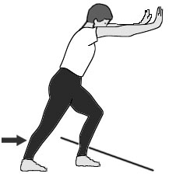

Repeat the exercise above but this time allow the back knee to bend slightly. You should now feel the stretch lower down in the Achilles tendon.

