www.npmc.org.uk
01908 619912
npmcprivateservices@gmail.com

Acute Ankle Sprain

What is a Sprain?

A sprain is an over stretching to tissues, usually the ankle ligaments.

This over stretching can then cause inflammation, swelling, bruising around the ankle and movement can be painful.

Treatment for a Sprained Ankle

From the initial injury up to 72 hours you need to follow the PRICE rule.

P rotect – a bandage or a tubigrip around the ankle will help prevent further injury.

R est – the ankle following the injury

I ce – Should be applied as soon after the injury as possible for 15- 30 minutes. The ice should be wrapped in a damp tea-towel to prevent burning of the skin. This helps limit inflammation. Repeat as many times as you can in the first 72 hours.

C ompression – a tubigrip or bandage will help prevent uncontrollable swelling – ask your pharmacist for the correct size. Remove this when asleep.

E levation – helps to control the swelling. When resting, put your ankle on a stool so that it is above your hip. When you are in bed put your foot on a pillow.

At all times you should keep your ankle moving to prevent the joint from stiffening up.

DO NOT: put heat on your ankle, massage your ankle, run on your ankle or drink alcohol as all of this will increase the blood flow to your ankle and therefore increase the swelling.

Walking Pattern

Even though your ankle is very painful and you should be resting, when you are walking you must try to walk as normally as possible, otherwise you may be putting unnecessary strain on other ligaments and muscles in your ankle. If walking normally is excruciatingly painful, you may need crutches to help you with this.
After 48 – 72 hours you should start to do the exercises on the leaflet to try and maintain good range at your ankle.

Exercise1

Relax leg. Gently bend and straighten ankle.

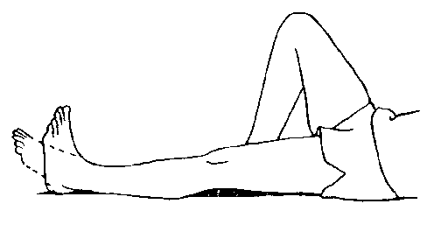

Exercise 2

Slowly rotate your ankle clockwise and anticlockwise.

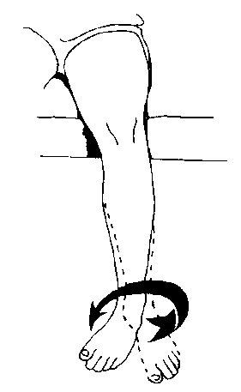

After 1 week to 10 days you will need to start some gentle strengthening exercises to improve the stability around the ankle joint.

Repeat all of these exercises 10 times, 3 times a day. Avoid pain with all exercises.

