www.npmc.org.uk
01908 619912
npmcprivateservices@gmail.com

Achilles Tendonitis

Causes and symptoms

Achilles tendinopathy can be due to repetitive overstrain, biomechanical strain or an injury. Symptoms may include pain, stiffness, swelling or weakness of the tendon. Pain and stiffness tend to develop gradually and are usually worse when you first wake up in the morning. Some people have pain during exercise but, in general, pain is worse after exercise.

Treatment

Rest from activities that aggravate the symptoms. This does not mean keeping completely immobile as this can lead to further weakening of the tendon.

Ice / Heat may be beneficial. In the case of new injuries (1 – 3 days old) it is best to use ice and not to use heat. After this time you can trial both. Apply for 15 minutes at a time twice daily.

Exercises Do both the exercises below twice daily
Hold each stretch for 20 seconds (do not bounce and you should not feel any pain)
Repeat 3 times each

Calf (Gastrocnemius) stretch Soleus stretch
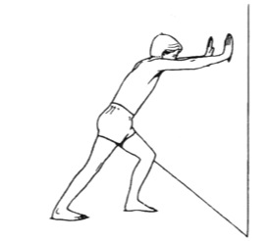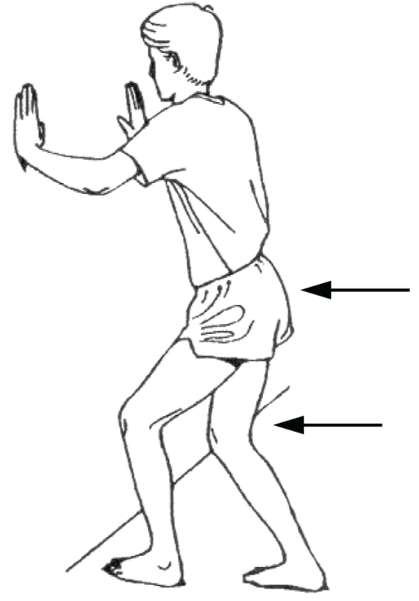

Other treatment Using a small wedge under the heel may reduce the strain on the Achilles and therefore reduce symptoms.

Your physiotherapist may also advise some specific strengthening exercises or orthotics for your foot ware.

