www.npmc.org.uk
01908 619912
npmcprivateservices@gmail.com

Lateral Epicondylitis
(Tennis Elbow)

Tennis elbow is the common name for a condition called lateral epicondylitis. This condition causes pain around the outside of your elbow.

What is tennis elbow?

Tennis elbow is usually caused by overuse of the forearm muscles, maybe due to an injury or many small injuries to the tendons for example twisting movements like using a screwdriver or gripping, however sometimes in a small number of cases tennis elbow can occur for no reason. It is usually an inflammation of the tendon that attaches to the bone.

Treatment options

Tennis elbow in most cases gets better on its own with rest from the aggravating factor (if known) and following the advice and gentle exercises in this leaflet. Start with exercises 1 and 2 and if pain decreases continue to 3, 4, 5 and 6. However if your symptoms do not settle then a course of physiotherapy may be helpful.

Medication

It is best to take some anti-inflammatory painkillers to help reduce your symptoms. Ask your GP or pharmacist about the best one for you to take.

Exercise 1

Keep your elbow straight, hold the involved hand and slowly bend wrist upwards as shown.
Hold 20 seconds and repeat 3 times.
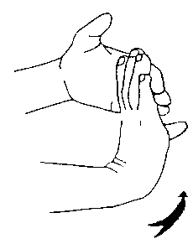
Exercise 2

Keep your elbow straight, hold the involved hand and slowly bend wrist downwards as shown.
Hold 20 seconds and repeat 3 times.

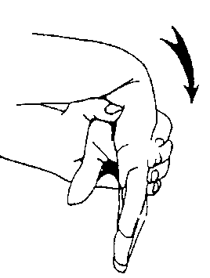

Exercise 3

Rest your forearm on a table with palm to the ceiling; resist upward movement of hand with opposite hand as shown. Hold 5 seconds and repeat up to 10 times.

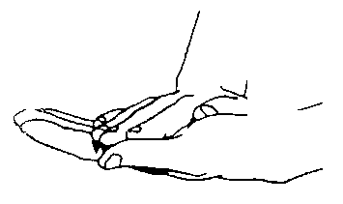

Exercise 4

Rest your forearm on a table with the palm down, resist upward movement of hand with opposite hand as shown. Hold 5 seconds and repeat up to 10 times.

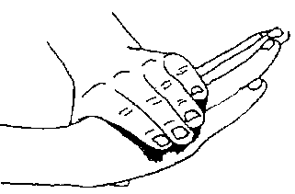

Exercise 5

Make a fist with the involved hand and squeeze tightly.

